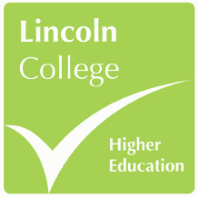
LINCOLN COLLEGE HIGHER EDUCATION
CAREER DEGREE BURSARY REQUEST FORM 2018/19

Please complete this form in full and submit to your course tutor, allowing sufficient time for the BACS payment to be made.
Name

Programme

Tutor

Spend category (delete as appropriate) | - Qualification  - Professional accreditation / membership  - CPD event  - Vocational placement  - Equipment / resources*
Further details (events)
If you are hoping to attend an event or course please provide details of:
- The course title and event organiser
- Venue
- Dates and times
- Cost

Further details (purchases)
Please provide details of:
- The specific item(s) – including reference or item codes
- Where they are being purchased from
- Cost

Justification
Please provide a justification for this request stating how this will benefit your career prospects and enhance your employability.

Bank details
Account holder name:

Sort code:

Account number:

Tutor decision
Accept ☐

Reject ☐

Tutor: ______________________________________

Signed: _____________________________________

Date: ______________________________________

Grounds for refusal (where appropriate):

* Note: This is not the primary purpose of career degree bursary funds, therefore you will not be permitted to allocate more than 1/3 of your total bursary funding on equipment and resources over the duration of your main programme (eg. £500 in total for full time students on 3 year programme).

