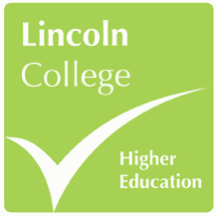
LINCOLN COLLEGE HIGHER EDUCATION
CAREER DEGREE BURSARY REQUEST FORM

Please complete this form in full and submit to your course tutor, allowing sufficient time for the BACS payment to be made.
Name

Programme

Tutor

Spend category (delete as appropriate) | - Qualification  - Professional accreditation / membership  - CPD event  - Vocational placement  - Equipment / resources*
Further details (events)
If you are hoping to attend an event or course please provide details of:
- The course title and event organiser
- Venue
- Dates and times
- Cost

Further details (purchases)
Please provide details of:
- The specific item(s) – including reference or item codes
- Where they are being purchased from
- Cost

Justification
Please provide a justification for this request stating how this will benefit your career prospects and enhance your employability.

Bank details
Account holder name:

Sort code:

Account number:

Tutor decision
Accept ☐

Reject ☐

Tutor: ______________________________________

Signed: _____________________________________

Date: ______________________________________

Grounds for refusal (where appropriate):

* Note: This is not the primary purpose of career degree bursary funds, therefore you will not be permitted to allocate more than 1/3 of your total bursary funding on equipment and resources over the duration of your main programme (eg. £500 in total for full time students on 3 year programme).

